A CLAS Information Technology Group document
Mac OS X Network Printing
Connecting to the IOWA domain print queues

Macintosh OS X

This guide details the general steps required to allow a workstation to utilize the centrally managed print queues overseen by ITS, making it easy to control troublesome printing problems. These directions can be applied to Mac OS X 10.6, 10.7 and 10.8 computers, whether bound to Active Directory or not.
Only the generic steps to connect a Mac OS X client to the print servers are covered here. Additional steps may be required to enable printer-specific options, such as stapler units or duplexers.
Download and/or install the necessary printer driver before adding the printer. Contact the Casper Team to have the proper driver added to Casper Remote if it doesn’t already exist.

Macintosh OS X 10.7 - 10.8 -- Printing from an AD bound Macintosh

- Click on the Apple Menu, select System Preferences and select the Print & Scan panel. This may be named slightly differently depending on the operating system, such as Print & Fax in Mac OS 10.6, or Printing & Scanning in 10.9.
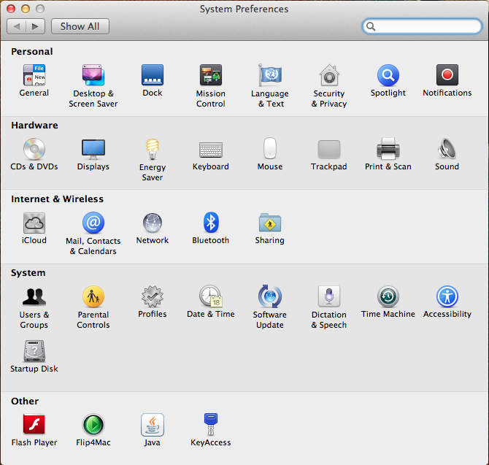

- Select the “+” button beneath the printer listing field on the left to begin adding a printer.

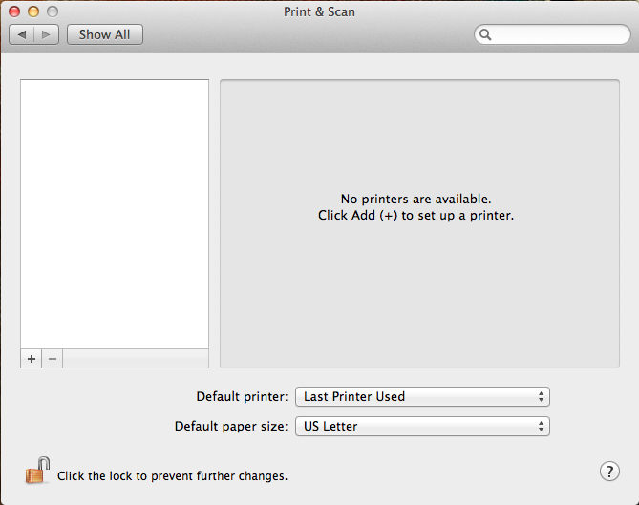

- Select the “IP” icon from the Add Printer toolbar.
  - Address: Enter the print server name (i.e. iowaprint04.iowa.uiowa.edu).
  - Protocol: Select “Line Printer Daemon – LPD”.
  - Queue: Enter the printer name (i.e. JH-311-MAIN).
  - Name: Enter the printer name again (i.e. JH-311-MAIN)
  - Location: Enter the printer location (i.e. JH 311)
  - Use*: Choose “Select Printer Software…” from the drop down menu and scroll to or search for the appropriate printer model.
*Note: If using OS X 10.6, this is labeled as “Print Using:”.

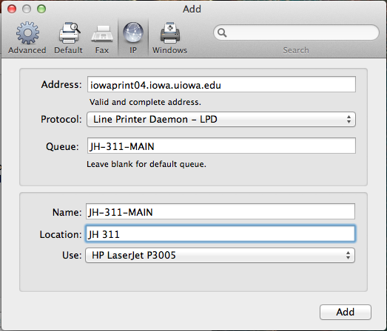

- Press “Add” to continue adding the printer. A new window will appear allowing you to install additional features specific to the printer.

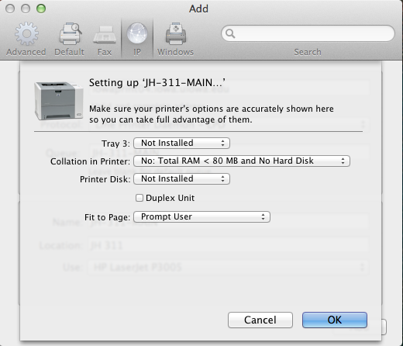

- Once you have selected the necessary features, press “OK” and you will be returned to the “Print & Scan” window. The printer is listed in the column on the left under “Printers” and you may now print to it.

