A CLAS Technology Services document

Using Remote Desktop and Mapping Network Drives from Off-Campus
Windows 7 & Macintosh OS X

This document explains how to use Remote Desktop Connection to access a Windows-based university computer and map network drives while off-campus. This document applies to both university-managed and personally-owned Windows or Macintosh computers. Remote Desktop allows you to remotely login to your university computer to utilize resources (software and network drives) as if you are actually sitting at that computer. Mapping a network drive to your computer allows you to access the files stored within that drive. Please work with your IT Support Consultant to determine which option is best for you.

Register University Computer With PowerUP!

Registering your computer with this tool allows you to remotely turn on your computer so you are able to access it using Remote Desktop Connection.

NOTE: This is not necessary if you only wish to map network drives. Please skip to the next section titled “Install & Configure Cisco VPN Client”.

- While signed in to the university computer you will be using Remote Desktop Connection to access, go to the ITS DIY Tools site, click the Login button and log in using your HawkID and password.

- Select the Tools tab on the top ribbon and click the gold PowerUp! header.

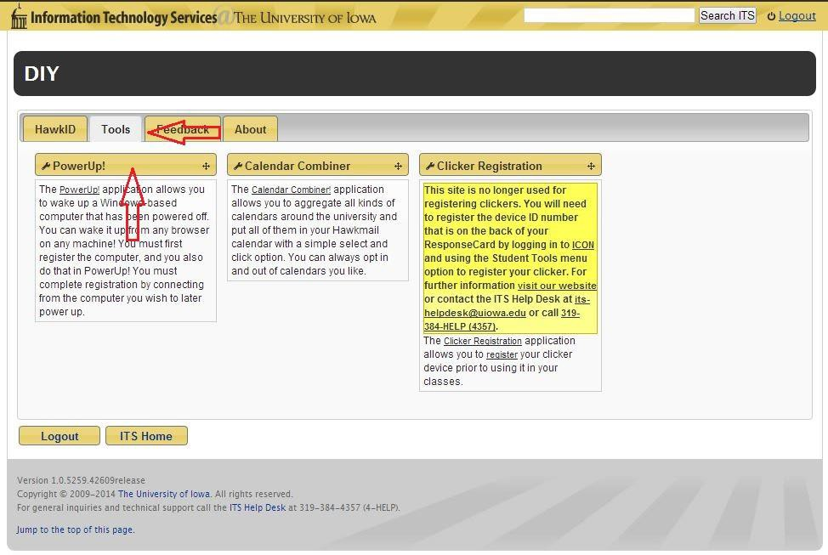

- A list of your computers currently registered with PowerUp! will appear. If your current computer is not in the list, select Add current computer.

NOTE: If your current computer is already listed, you may use the alarm clock icon to the left of the computer name to remotely turn on this computer in the future. Skip to step 7 in this section.

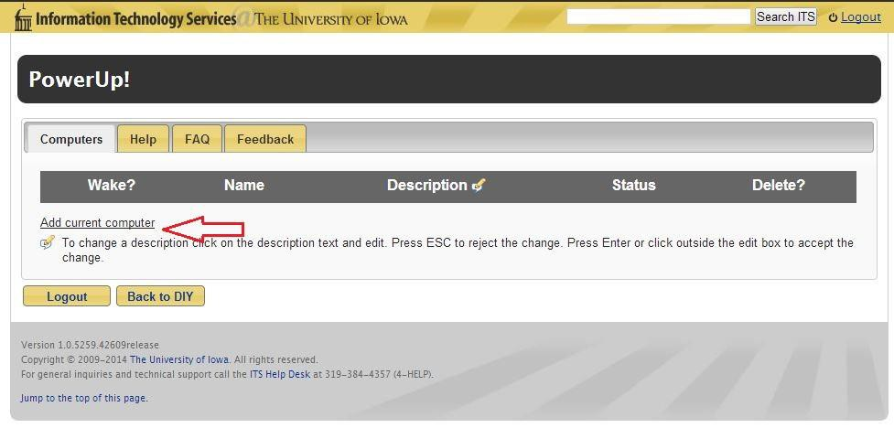

- The System Information window will appear.
  - Description: Enter a description for the computer you are registering.
  - Full Computer Name: enter the computer name followed by “.iowa.uiowa.edu” without quotations. Click on the blue question mark icon for help finding your full computer name.
  - Physical Address: Enter the physical address of your computer. Click the blue question mark icon for directions on finding this information.
  - Click the Register button to continue.

NOTE: Please contact your IT Support Consultant if you need help filling out any of these fields.

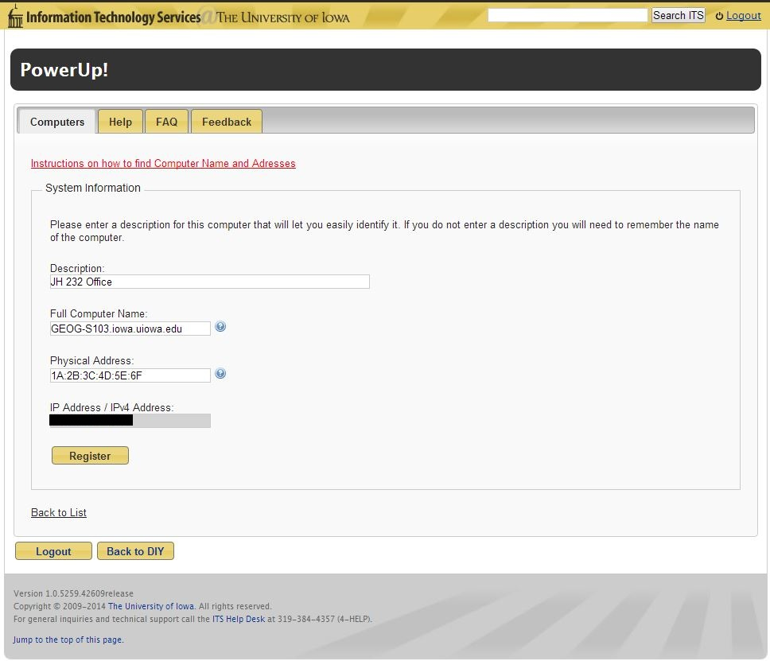

- You will be returned to the main PowerUp! window and your current computer will now be displayed in the list of registered computers.

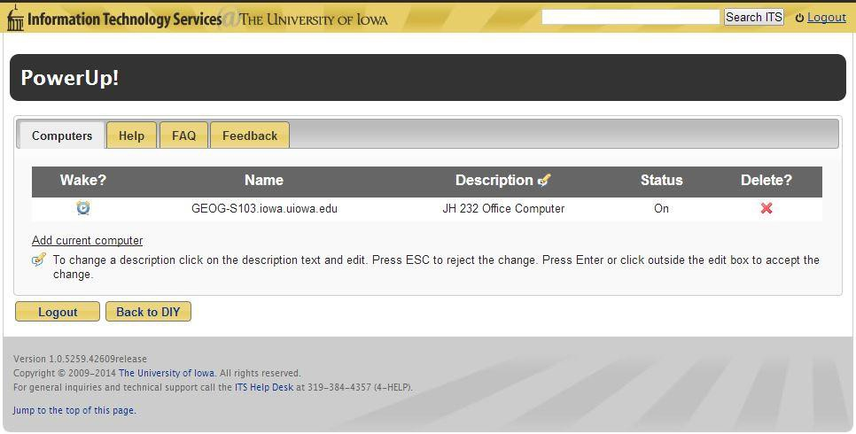

- To remotely turn on your computer in the future, repeat steps 1 and 2. Once you reach the main PowerUp! window, the current status of your computer is displayed. If it is listed as Off, click the alarm clock icon to the left of the computer name to turn it on.

- You will be taken to the status window where you may check the status of your computer to determine if it is fully powered on yet by clicking Check Status.

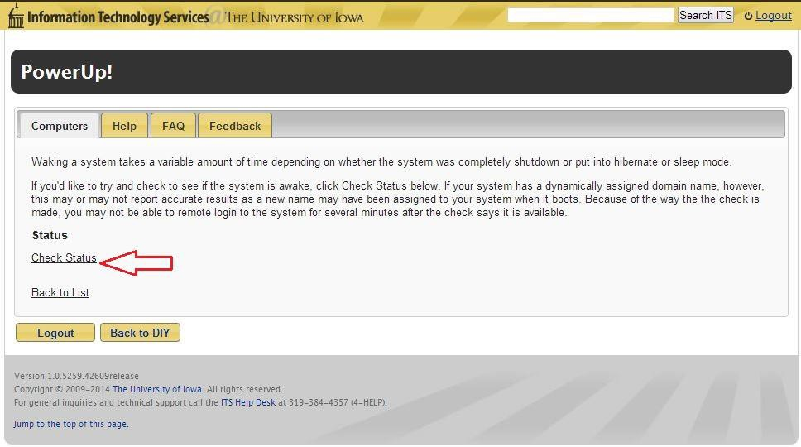

Install & Configure Cisco VPN Client

In order to access university resources from off-campus you must have the VPN client installed and be connected to the Iowa domain. If you are using a university-managed computer, the Cisco VPN Client should already be installed for you (skip to step 3 below). If you are using a personally-owned computer please follow the steps below to download, install and configure the Cisco VPN Client.

- Visit the ITS Software Download site and sign in using your HawkID and password. You may need to specify the Iowa domain by typing iowa\ before your HawkID.

- Click on the Cisco AnyConnect VPN Client link.

Windows: Select AnyConnect for Windows to begin downloading the installer. Save the installer to a location on your computer. When the download is complete double-click the file to begin the installation. Accepting all defaults, follow the instructions on the screen until the installation has completed.

Mac OS X: Select AnyConnect for Mac (Intel) if you are running OS X 10.8 and below and AnyConnect for Mac (Intel) 10.9 ONLY if you are running OS X 10.9. When the download is complete, double-click the .dmg image file and double-click the .pkg file to begin the installation of the VPN client.

NOTE: If you are using Mac OS X 10.8, you will need to disable the Gatekeeper feature in order to install the VPN Client. You may re-enable Gatekeeper after the installation and initial launch of the application. Please click here for instructions on turning off Gatekeeper.

- Once the installation is complete, launch the VPN client:

Windows: Go to the start menu, select All Programs, Cisco folder, Cisco AnyConnect Secure Mobility Client folder and select Cisco AnyConnect Secure Mobility Client.

Mac OS X: Go to Applications, Cisco and select Cisco AnyConnect Secure Mobility Client.

- In the window that appears, enter vpn.uiowa.edu and click Connect (may also be Select depending on your version of OS X).

Windows:

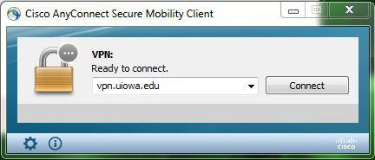

Mac OS X:

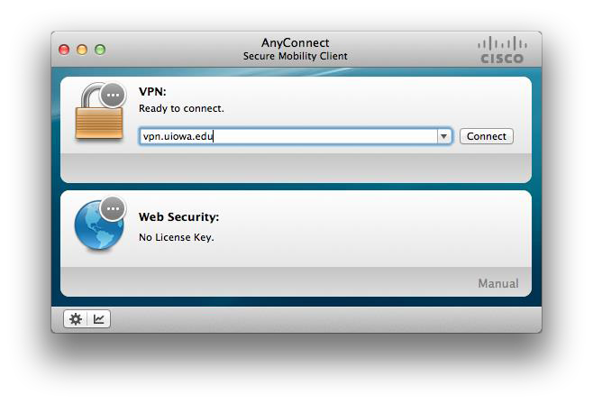

- Leave the Group dropdown set to Default. Enter your HawkID and password in the prompt that appears (do not enter iowa\) and hit OK. You should now be connected to the Iowa domain.

Windows:

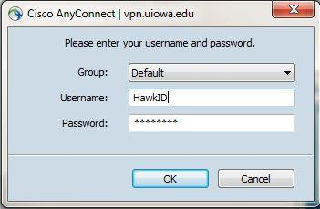

Mac OS X:

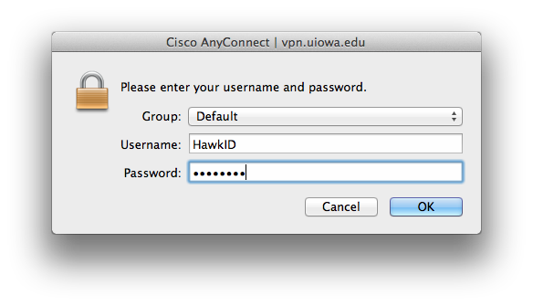
Option 1: Remote Desktop

Work with your IT Support Consultant to ensure you are authorized to remotely access your university computer. The Cisco AnyConnect Secure Mobility Client must be running to use Remote Desktop Connection.

- To use Remote Desktop Connection to connect to your university computer:

Windows: Go to the start menu, select All Programs, Accessories, Remote Desktop Connection.

Mac OS X: Go to Applications and select Remote Desktop Connection for Mac.

For a CLAS-managed Mac, Remote Desktop Connection for Mac should already be installed. For personally-owned Macs, you may download Remote Desktop Connection for Mac for free from Microsoft or the Mac App Store.

- In the Remote Desktop Connection window, enter your computer name followed by .iowa.uiowa.edu.

Windows:

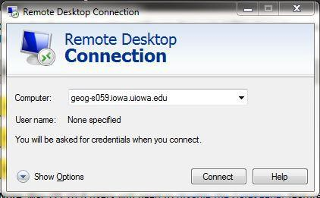

Mac OS X:

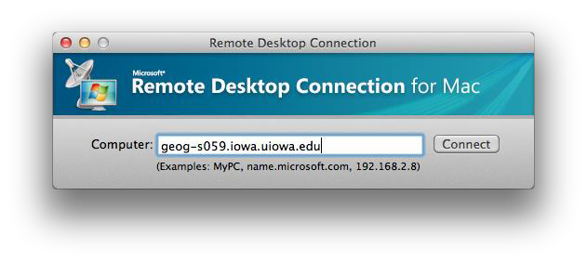

- Upon clicking Connect, you will be prompted to enter your HawkID and password. Make sure to enter iowa\ before your HawkID.

- A window will appear referencing a security certificate. To continue the logon process select either Yes on a Windows computer or Connect on a Mac and you will be logged in to the specified computer.

Windows:

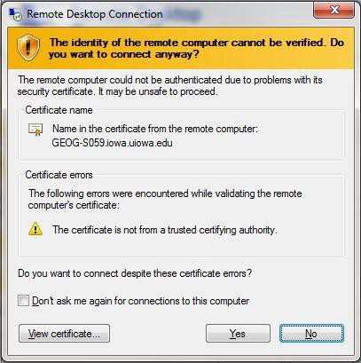

Mac OS X:

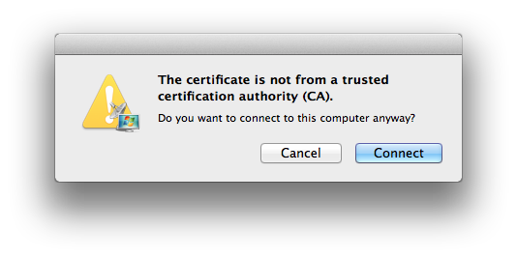

- If you receive the following window after hitting Connect, it is likely that your university computer is not powered on. Please refer to the first section in this document on using the PowerUp! tool to remotely turn on your computer.

Windows:

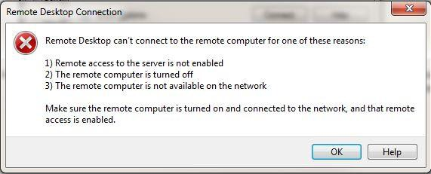

Mac OS X:

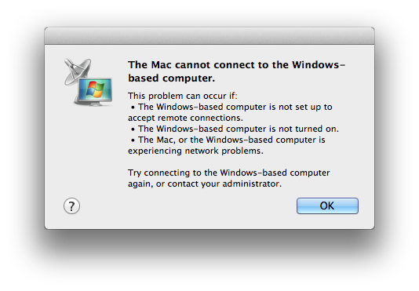

Option 2: Map Network Drives

The Cisco AnyConnect Secure Mobility Client must be running in order to map a network drive. Please work with your IT Support Consultant to ensure you have the necessary addresses to your network drives. For your reference, several common network drive paths are listed at the end of this document.

Mac OS X users: If you are using a version of Mac OS X earlier than 10.7.4 please contact your IT Support Consultant for the necessary network drive addresses.

NOTE: You will need to repeat these steps after logging out and back into your computer. The Cisco VPN Client also times out after a certain period of inactivity. You will need to reestablish that connection to access any network drives that have been previously mapped.

Windows:

- Go to the start menu and open My Computer. Select Map network drive at the top.

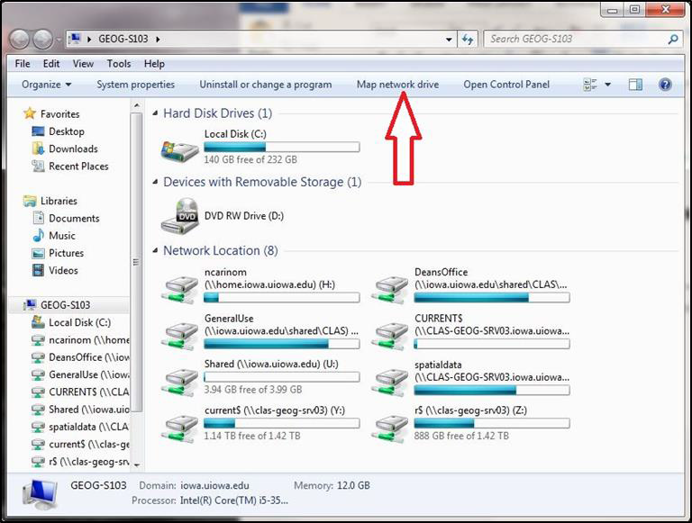

- The Map Network Drive window will appear.
- Drive: From the dropdown menu select an unused letter, preferable something towards the end of the alphabet.
- Folder: enter the desired address to the shared drive that you wish to connect to.
- Check the box next to Connect using different credentials.
- Select Finish and enter iowa\HawkID and your password when prompted.

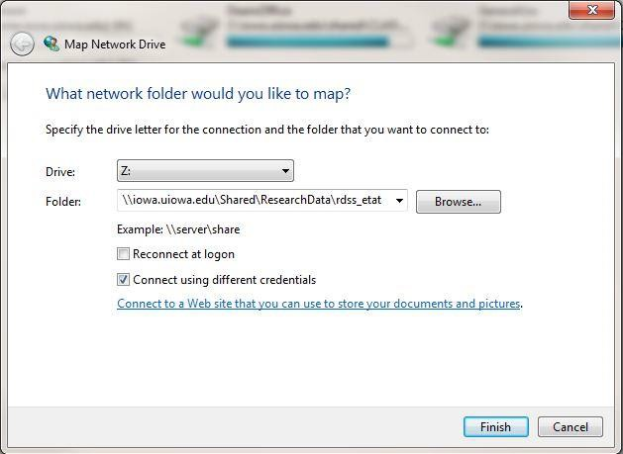

- A new window will appear showing the contents of the drive you just mapped. You can access this drive again by going to My Computer.
Mac OS X:

- Under the Go menu, select Connect to Server.

- Under Server Address in the Connect to Server window, enter the address of the network drive you wish to connect to and hit Connect.

NOTE: You may also click the + button to add this server to your Favorite Servers list for future use.

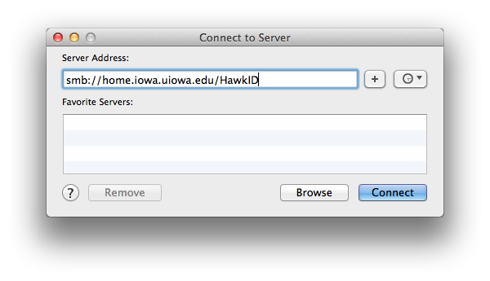

- In the window that appears, check the button for Registered User, enter your HawkID and password and click Connect.

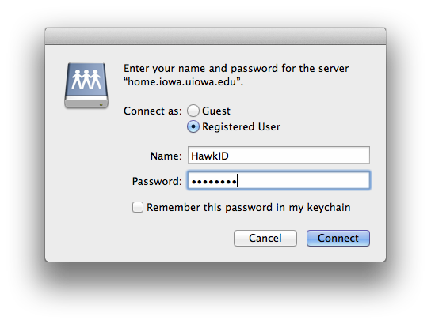

- A window will appear showing the contents of the network drive you just mapped. The network drive will now be mounted on your desktop for future access.

Notable Network Drive Paths:

Home Drive (H:):
Windows: \\home.iowa.uiowa.edu\HawkID
Mac OS X: smb://home.iowa.uiowa.edu/HawkID
Departmental Drive (L:):
Windows: \\iowa.uiowa.edu\Shared\CLAS\Departmental\DepartmentName
Mac OS X: smb://iowa.uiowa.edu/Shared/CLAS/Departmental/DepartmentName
General Use Drive (N:):
Windows: \\iowa.uiowa.edu\Shared\CLAS\GeneralUse\DepartmentName
Mac OS X: smb://iowa.uiowa.edu/Shared/CLAS/GeneralUse/DepartmentName
Research Data Storage Space (RDSS Drive):
Windows: \\iowa.uiowa.edu\Shared\ResearchData\rdss_HawkID
Mac OS X: smb://iowa.uiowa.edu/Shared/ResearchData/rdss_HawkID

